TEACHERS’ INFORMATION PACK

Contents

Section 1

Pre-visit Information Pg 2

Section 2
The Countryside Classroom Pg 6

Section 3
On the Farm Pg 10

Section 4

Low Stanger Farm Pg 14

Section 5

What Low Stanger Farm can offer Pg 21

SECTION 1: Pre-Visit Information
Welcome
Thank you for your interest in visiting our farm. We hope that the experience will give your pupils inspiration and information.
The visit allows pupils to see for themselves how a modern farm works, in an enjoyable and safe environment.
This pack will help you to prepare a successful programme tailored to suit the needs of your group.
What is farming?
Farming is the age-old practice of producing crops and livestock for food, fuel and fibre. The origins of human civilisation are closely linked to the development of farming when primitive hunter gatherers were gradually replaced by farmers producing the first domesticated plants and animals.
Modern agriculture is a highly competitive global industry. The UK produces 70% of the food we eat, the rest coming from other parts of the world. It is the first link in a sophisticated chain to prepare and process our food before we buy it in the shops. What a farmer grows depends on individual circumstances such as location, weather conditions, size of the farm, history of the area and market forces.
Farming has created the landscape that we see. It is the hedges and walls that divide fields that give the landscape its pattern, along with areas of trees and the colours of different crops. By carrying out activities such as cutting hedges and planting trees, farmers are helping to look after much of the wildlife in the countryside.
Many farmers also now operate broader enterprises to include leisure activities and environmental management. Defra provides advice and funding through agri-environment schemes to encourage farmers to follow farming methods that enhance the landscape, encourage wildlife, protect resources, archaeological and historic features and improve opportunities for enjoying the countryside, by providing access. By conserving our countryside in this way we also play our part in the international agreement to maintain the natural diversity of animals and plants throughout the world.

Farm Information
Contact details:
Farm name: Low Stanger Farm and Market Garden
Farm address:
Low Stanger Farm
Stanger
Cockermouth
Cumbria
Contact person: Michelle Hughes
Post code: CA13 9TS
Tel no: 01900 823558
Mobile no: 07770 614707
Email: enquiries@lowstanger.co.uk
Website address: www.lowstanger.co.uk
Booking a visit:
In the first instance, please telephone the farm. We can then discuss your requirements, and arrange a suitable date. A pre-visit is usually recommended, especially for a first visit, or a new activity.
Visits are free but you will need to organise and pay for transport. I will send a confirmation letter if required once a date has been agreed.
Cancellation arrangements:
If you are unable to carry out your visit, please let us know as soon as possible so that we can make alternative arrangements.
How to get here:
Grid reference: NY 31375277

Stanger is approximately 2 ½ miles South of Cockermouth. Low Stanger Farm is situated within the settlement of Stanger itself.

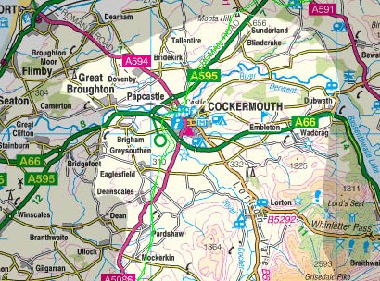
Map showing location of Low Stanger Farm
Low Stanger Farm
Arriving from West Cumbria (Workington and Whitehaven)

Leave the A66 at the second Cockermouth junction (Sheep and Wool Centre) and proceed towards the town centre. At the traffic lights at the junction of Station Street and Lorton Street, turn right (this is obligatory at this junction in any case. Follow this road for about 1½ miles, past Hundith Hill Hotel. Turn right at the next crossroads, which are at the top of the hill (to Eaglesfield & Brigham). Take the first left (150m). This no through road ends at Stanger. Please park in the farm’s stackyard, which is an area of hard standing approximately 100 metres from the settlement, on the right hand side of the road.

On arrival:
Please alight in the stackyard. The surface is reasonably hard, and will take a large vehicle safely, but often the surface is quite wet and muddy – wellies will be required for most of the year. You will be met by Michelle or Peter. You will then be guided down to the farmyard (through the market garden field) for a safety briefing and basic information about the farm. If the weather is favourable, the briefing will be done in the stackyard.
Facilities:
These are limited at the moment – there is one toilet and one wash hand basin, plus cold water points for welly washing etc.
We do not plan to develop an area for lunches to be eaten, but we do have a covered area for wet-weather activities, briefings etc. If the weather is favourable, it may be possible for children to have packed lunches outside

Evaluation Form:
This visit is provided free of charge. In order for us to be able to claim a payment as part of our Higher Level Stewardship agreement with Natural England, we require that you complete an evaluation form which we will provide. Please take a few moments to complete this form after the visit and hand it to us before you leave. Additional feedback regarding the visit would be welcome, in particular on what we can improve, and if ‘outreach’ activities at the school (for example we have previously done ‘apple day’ activities in local schools, where we talk about apples, and bring samples for the children to try) would also be useful.

Complaints procedure:
If you have any complaints regarding your visit please inform us so that we are able to improve our service. You may also write to:
Department for Environment, Food and Rural Affairs
Rural Development Service
Access Management Unit
Woodthorne
Wolverhampton
West Midlands
WV6 8TQ

Section 2: The Countryside Classroom
The countryside offers an invaluable teaching resource. The visit can be used to teach all aspects of the curriculum through learning about farming and the countryside. We hope that this information pack will give you ideas to inspire your pupils and get the most out of your visit.
Please note that we regularly update this Teachers Information Pack. It would be greatly appreciated if following your visit you pass to us any lesson plans, activity ideas or worksheets that have been successfully used on our farm so that they can be incorporated into our pack if appropriate. Please list any equipment needed for the activities

Learning opportunities
Scope of Work

Fruit and Vegetables
Food processing Retail, e.g. farm shops
Co-operatives Herbs Dairy products Meat
Drinks and beverages Farmers’ markets Speciality products

Sugar Food production & services Cereals

Environmental management

Nature Reserves Woodlands Wildlife conservation
Archaeological conservation Habitat maintenance & creation

Landscape management
Access & leisure
Non-food goods & services
Pathways

Leisure
activities


Pharmaceuticals
Retail, e.g. garden centres
There are many ways in which farming and growing can enrich the curriculum. Some examples from the Department for Education and Skills Growing Schools initiative are included above.
Timber
Cosmetics
Horticulture
Industrial products
Energy crops
Tourist services
Visitor attractions
Accommodation
Heritage

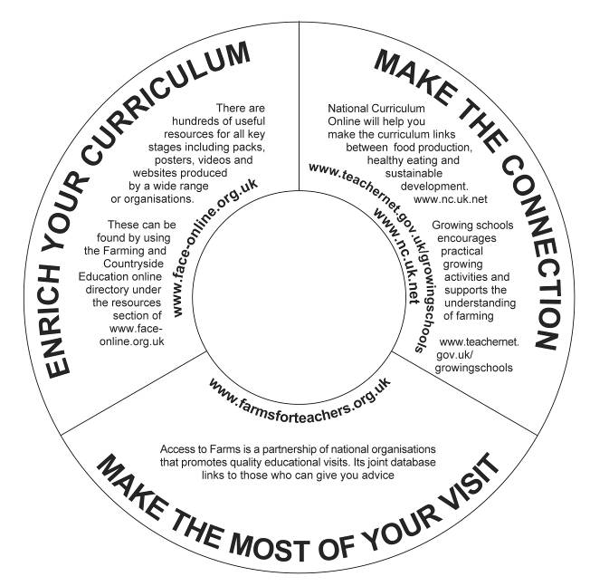

Links to the National Curriculum
At Key Stage 1 the farm visit can widen the pupils’ first-hand experience in a whole range of visual, tactile and other sensory situations. Within this are the important messages of the life cycle and seasonal change. There is a wealth of opportunity for language development and literacy skills.
At Key Stage 2 the visit can stimulate and excite pupils’ curiosity. It also satisfies their curiosity as they begin to apply their knowledge and understanding of ideas. Pupils can consider the farm as a good example of an environment affected by human activity, think about attitudes to farming, the rural environment and the conflicts of interest that arise.
They talk about their work and its significance and communicate their ideas using a wide range of language.
At Key Stage 3 many different subject requirements can be satisfied. For example in history, the adaptation of farm buildings over the centuries can offer first-hand evidence of social and technological changes. This readily promotes the skills of handling and assessing. Pupils can investigate and debate a wide range of complex issues and begin to understand the environmental, social and economic implications.
At Key Stage 4 farm visits can be used to deliver examination subjects both academic and vocational. Contact with farmers will help to focus on the real life application of skills within the workplace, engaging pupils with contemporary issues and focusing on their role as users and consumers.

Section 3: On the Farm
Risk Assessment
We recommend a pre-visit to our farm, during which you can carry out a risk assessment and become familiar with the site. Any specific requirements or needs of the visiting group can be discussed. A copy of the farm’s risk assessments are available on request.
Health & Safety
We comply with Health and Safety Regulations. However it is important that all pupils and supervising adults are aware of the correct Health and Safety guidelines.
The risk of infection is very small, but disease caused by an infection could be serious. By following simple guidelines, similar to everyday basic hygiene recommendations, the risk can be easily minimised.
The Health & Safety Executive has produced guidelines, HSE sheet AIS23 – Avoiding ill health at open farms – Advice to farmers. The supplement to AIS23 advises teachers and others who organise farm visits on controlling the risk of infection from animals which the pupils may have contact with during their visit.
All animals naturally carry a range of micro-organisms, some of which can be transmitted to humans, causing ill health. Some, such as the bacterium Escherichia coli O157 (E coli O157) cause infections which can potentially cause disease, which may be particularly acute in young pupils.
While the hazard from infection resulting from a farm visit is real, the risk can be readily controlled by following sensible steps which will help make your visit safe, healthy and enjoyable.
- Read and understand the advice in AIS23, and discuss visit arrangements with the farm management. Assure yourself that the facilities provided match the recommendations in AIS23.
- Decide what the ratio of pupils to teachers/assistants/parents should be, using advice from your local authority. As a general rule, the ratio of supervisors to pupils should be 1:1 for pupils under 1 year old, 1:2 for pupils between 1 and 2 years old, 1:3 for pupils between 2 and 3 years old, 1:4 for pupils between 3 and 5 years old, and 1:8 for those between 5 and 8 years old. If supervision levels are less than this, you should not allow direct contact with any animal for pupils under eight. The ratio of supervisors for pupils between 9 and 11 years old should be 1:10-15, and 1:15-20 for pupils from 12 years old and above. These are examples only and group leaders should assess the risks and consider an appropriate safe supervision level for their particular group.
- Discuss with the supervisors, who may be parents or staff of the school, creche, etc. their role during the visit. They must understand the need to make sure that pupils wash, or are helped to wash, their hands thoroughly after contact with animals, and follow the other rules suggested below.
- Discuss with pupils the rules for the visit, stressing that they must not eat or chew outside the areas in which you permit them to do so.
- Check that cuts, grazes, etc. on pupil’s hands are covered with a waterproof dressing.
Clothing
Make sure that pupils wear appropriate clothing, including sturdy outdoor shoes (not sandals) or wellington boots if possible.
Behaviour
Teachers/group leaders are responsible for the pupil’s behaviour throughout the visit. Pupils’ should understand how to behave on the farm and always follow the Countryside Code (see overleaf).
During and after the visit, make sure that the pupils:
- Do not kiss animals.
- Always wash their hands thoroughly before and after eating, after any contact with animals, and again before leaving the farm.
- Eat only food that they have brought with them, or food for human consumption that they have bought on the farm, in designated areas, and never eat food which has fallen to the ground, or taste animal foods.
- Do not suck fingers or put hands, pens, pencils or crayons, etc. in their mouths.
- Clean or change their footwear before leaving, remembering to wash their hands after any contact with animal faeces on their footwear.
- Allow plenty of time before eating or leaving so that they do not have to rush.
Check that pupils’ stay in their allocated groups during the visit, and that they:
- Do not use or pick up tools (e.g. spades and forks) unless permitted to do so by farm staff.
- Do not climb on to walls or animal pens, machinery, etc.
- Listen carefully, and follow the instructions and information given by the farm staff.
- Approach and handle animals quietly and gently.
- Do not chase, frighten or torment the animals.
You should supervise them during the visit, especially during hand washing, to make sure that each pupil washes thoroughly. Farm staff may be able to help with this supervision.
If a member of your group shows signs of illness (e.g. sickness or diarrhoea) after a visit, advise them or their parent/guardian to visit the doctor and explain that they have had recent contact with animals.
Further information:
Copies of the AIS23 information sheet and supplement and other useful Health and Safety leaflets are available free from HSE Books, PO Box 1999, Sudbury, Suffolk CO10 2WA
Tel: 01787 881165
Fax: 01787 313995
Website: www.hsebooks.co.uk
©HSE
The Countryside Code:
- Be safe – plan ahead and follow any signs
- Leave gates and property as you find them
- Protect plants and animals and take your litter home
- Keep dogs under close control
- Consider other people
www.countrysideaccess.gov.uk
Education packs are available from countrysidecode@face-online.org.uk

How to behave on the farm
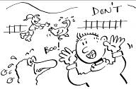

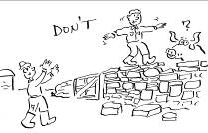
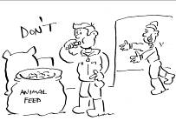
If you walk with your group leader, it is safer and will not frighten the animals.
The animals have a balanced diet so avoid feeding them, unless asked to.
Do not handle farm equipment or machinery unless permitted to do so by farm staff
Climbing on walls, fences or animal pens can be dangerous.

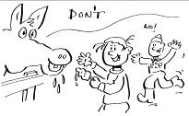
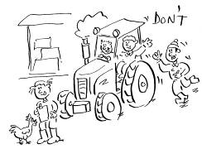

Eating animal feed could make you ill.

SECTION 4: Low Stanger Farm

Farm details:
Low Stanger is a 55 acre lowland farm; in the recent past, there were many similar family farms in the valleys around Cockermouth and Lorton. Development pressure, especially the conversion of farm buildings to dwellings, and the increased mechanisation of agriculture has drastically reduced the number in recent years, and most farms in the area tend to be much bigger, and specialised in livestock only.
We run Low Stanger as a mixed enterprise farm; our main agricultural activity is growing of certified organic vegetables and fruit (mainly apples). We also have a small flock of laying hens (for eggs), and we rent some of the pasture to a shepherd for year-round grazing of sheep. We also manage about one quarter of the farm in a conservation programme aimed at increasing the bio-diversity of both flora and wildlife. As part of this programme we keep a small number of traditional breed cattle. The cattle graze in a different way from the sheep, and their presence encourages a more diverse sward in the fields.
In order to run the farm as efficiently as possible, we have machinery for both market gardening and general farm work. The market garden equipment is small and light, so as not to damage and compact the soil. The general farm equipment is also relatively small, as the fields and lanes around the holding are often narrow.
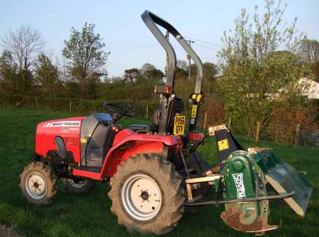
Market Garden tractor and rotovator

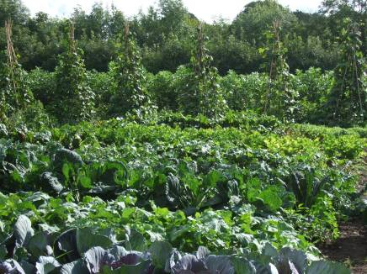
Market Garden in high summer
.
Farm buildings:
The farm buildings are mainly Seventeenth and Eighteenth century, and are typical of the range of buildings on a small, mixed Lakeland farm. There are two byres, with haylofts above, one barn and one converted house or cottage. This cottage seems to have been converted into a byre and hayloft about one hundred years ago, and has not been permanently inhabited for a long time.
Byres were used for housing cattle, especially over the winter months, but also for milking all year around. The lofts above the byres were for storage of hay and other fodder. The barn had an important role in storing the farm’s crops – especially the corn crops (oats, wheat and barley). Corn was the main farm product for most of the farm’s history, but this has locally been completely displaced by livestock since the middle of last century.

The enormous changes in farming practice in the last few decades have made these old farm buildings practically redundant on most farms. We use our buildings for a mixture of uses – storage of machines and equipment, crop storage e.g. for apples, onions and hay, and animal housing.

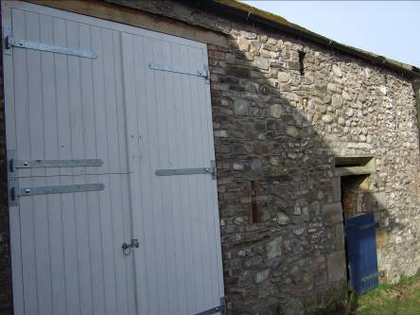
18th Century byre, with Victorian barn door addition, South End of yard, Low Stanger Farm
History:
Low Stanger was a Quaker farmstead for many years, certainly up until 1832, when the family line that had owned the farm many generations died out, and the farm was bought by a Workington solicitor. His family owned the farm, as part of a small estate, until 1953, and acted as landlords for a succession of tenant farmers. One such tenant family were the Rotherys, who farmed here in the final decades of the 19th century.

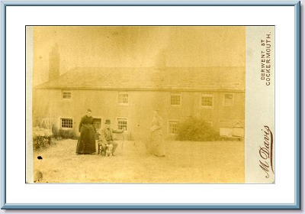
The Rothery family at Low Stanger around 1890
Soil:
The soils of the farm are largely glacial drift, with some silty, sandy soil in the fields near to the river. The soil in the market garden fields is classified as silty clay loam, on other parts of the farm there is less silt, and more clay. However, in general the soils are reasonably well drained and deep. In many places, neglect has led to the blocking of land drains, and this has led to localised waterlogging and the growth of soft rushes (‘sieves’) and other clump-forming plants.
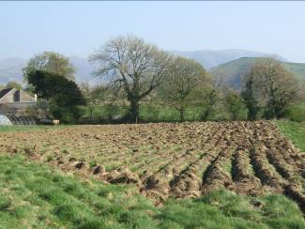
Silty clay loam soil after ploughing
Landscape:
Low Stanger is a typical lowland Lakeland farm, occupying the valley bottom adjoining the river Cocker. The land is undulating, and is mainly classed as ‘Ancient Farmland’. That is, the field boundaries pre-date the enclosures of the early 19th century, and in all likelihood date back to the earliest period of settlement. It is not clear when this initial settlement took place, but certainly pre-medieval.
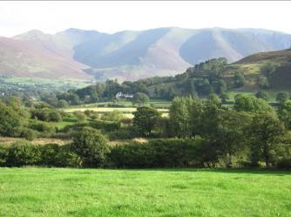
View from the farm towards Lorton
Climate:
The climate here on the edge of the Lake District is mild and wet, and is similar to the climate in the rest of West Cumbria, with a relatively small ‘mountain’ influence. Rainfall averages around 1100mm, fairly evenly spread through the year, with April and May usually the driest months, and September and October often the wettest. This means that harvesting often has to be completed in wet, changeable weather, which whilst difficult for vegetables, is even more tricky for crops like wheat, which require heavy machines. Strong winds are of course a real feature of our weather, and this does bring problems, especially for the orchard crops
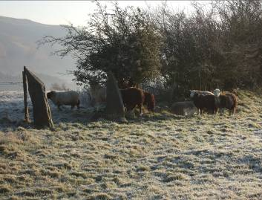
The farm in midwinter

Who lives and works here:
Low Stanger is run as a family farm – the family provide all of the labour, with occasional help from contractors for jobs like fencing. We also work away from the farm in order to supplement the farm income.
Involvement under Environmental Stewardship Scheme:
Low Stanger Farm is run under the Higher Level Stewardship scheme, a land management system designed to conserve field boundaries and buildings on the farm, and to encourage bio-diversity by methods like tree planting and restricting grazing. In addition, all of the tillage land is certified organic. Organic cultivation is a system which forbids the use of pesticides, herbicides and artificial fertilizers. Organic farms consequently tend to have a wider number of species present.
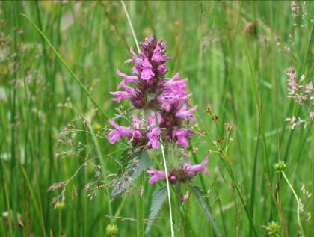
Wild flowers in Tarn Dale – Low Stanger Farm. This field is specifically managed to promote biodiversity
Special designations:
Stanger is on the Western edge of the Lake District National Park, and sits near the head of the Lorton Valley, one of the most beautiful, and agriculturally rich, of the Lakeland valleys. The river Cocker, which runs through the farm, is a Site of Special Scientific Interest. The river supports a wide range of species, including Salmon, Sea Trout (both migratory fish), Otter, Lamprey and Kingfisher.

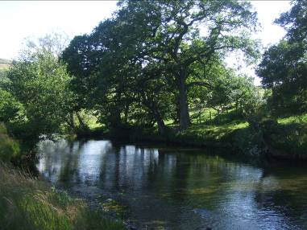
River Cocker (SSSI) runs through the farm, and supports many interesting species
Other enterprises:
The main farm enterprise is the market garden, but we also run a small self-catering cottage on the farm, as well as selling crops like hay.

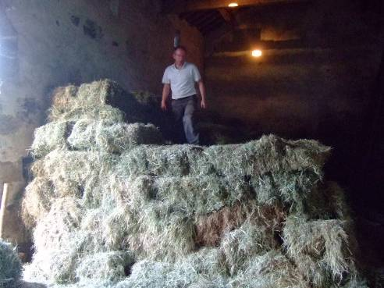
Stacking hay in the barn

Section 5: What Low Stanger Farm has to offer

Low Stanger Farm is an example of small-scale food production, with all produce consumed within the local area.

There are a number of activities that we can offer, depending upon the year group, and any particular areas of the curriculum that you would like to cover.

So far, children visiting the farm have participated in:-

Plant hunt – matching up photographs of vegetables with the crops growing in the fields (learning where the common, and less common vegetables grow, and how they appear in the ground)

Planting-out of vegetable crops into prepared ground (learning basic marking-out and planting skills, care of young plants, texture of soil etc)

Counting the number of trees in the orchard (a fun activity that allows the children to appreciate the number and types of trees, whilst working largely unsupervised in a safe environment)

Apple tasting session – children have the chance to sample a variety of less familiar apples varieties, and score them for appearance and flavour (learning about the large range of apple shapes and tastes, over and above the familiar supermarket brands)

Onion stringing – children create their own string of onions to take home, or for school use. (Supervised activity allowing children to handle the crop in harvested condition, and to create a useful food item)

These are just a few examples – we can also offer more specific and detailed activities for older children (e.g. GCSE Geography classes who wish to study organic farming systems), and also activities based upon conservation and wildlife themes (e.g. beck dipping, looking at insect life, installing bird boxes etc).

We can also offer ‘outreach’ visits to the school – in the past we have held ‘apple days’ at primary schools, where we have taken a selection of apples into the classroom for the children to see and taste.

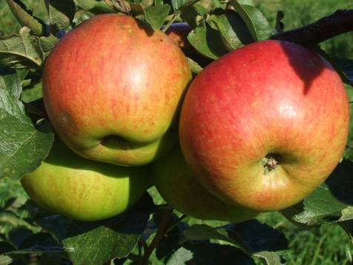
Organic apples (Malster) in the orchard

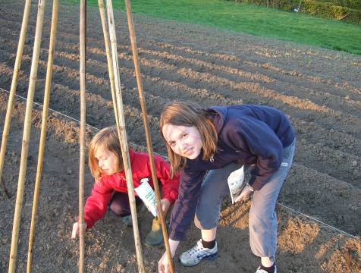
Planting beans in the market garden

 
 
 
 
 
  Section 2: The Countryside Classroom
  Section 2: The Countryside Classroom
  Section 2: The Countryside Classroom
  Section 2: The Countryside Classroom
  Section 3: On the Farm
  Section 3: On the Farm
  Section 3: On the Farm
 
 

